**SOFTWARE QUALITY ENGINEERING**

**PROJECT PHASE: 2**

**Muhammad Hassan**

**F2018065184**

**Tool Name:**

Test Project

**Description:**

TestProject is a free end-to-end test automation platform for web, mobile, and API testing. TestProject has become the part of the Tricentis product family, expanding Tricentis position as #1 in test automation with added support for open-source testing. It is absolutely free of cost and no hidden charges for using. Also, it is community powered anybody can contribute

**URL:** htttps://testproject.io/

**Name of the Application:**

Dorm Finder (FYP)

**Description of the web Application:**

Students come from different cites of Punjab to study in Lahore. In this way they must have to stay somewhere in city. Their first priority is to find best accommodation near their universities. Our web-based application will provide them a facility to book a dorm online nearer to their universities. Students can search dorm rooms according to their financial capability and can pay online through our online payment method. They can find dorm of their desire. Job holders and university staff can also easily access dorm. Dorm owners can register their dorm by providing true and fair information. Admin will approve by verifying the information.

**First of all, you need to sign up in the TestProject by clicking that link. And put your information and verify it.**

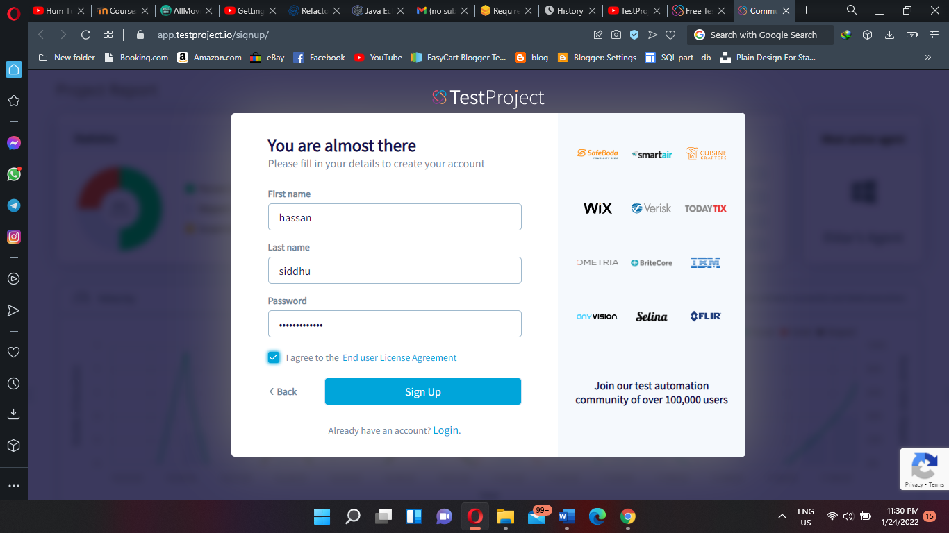

**After successfully logged in you have to create a test case where you want to apply the test case.**

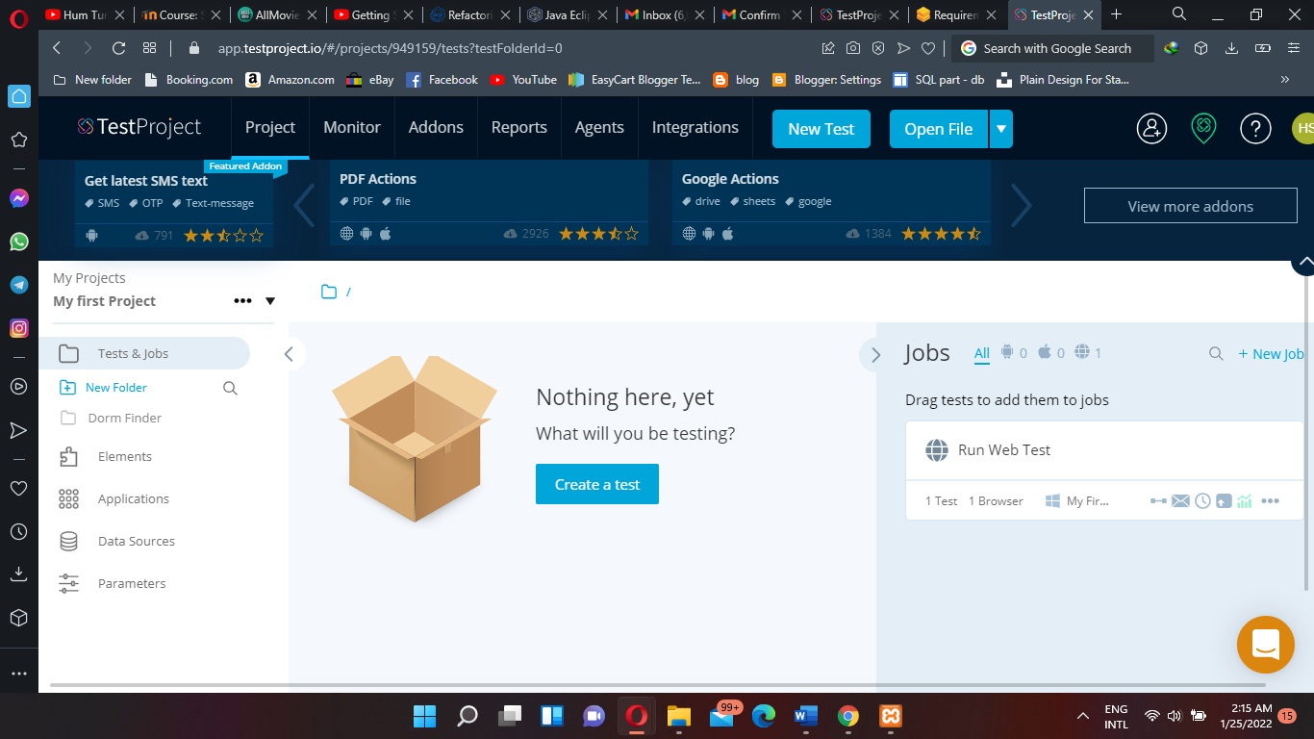

**After clicking on create a test you have to write the detail about test case**

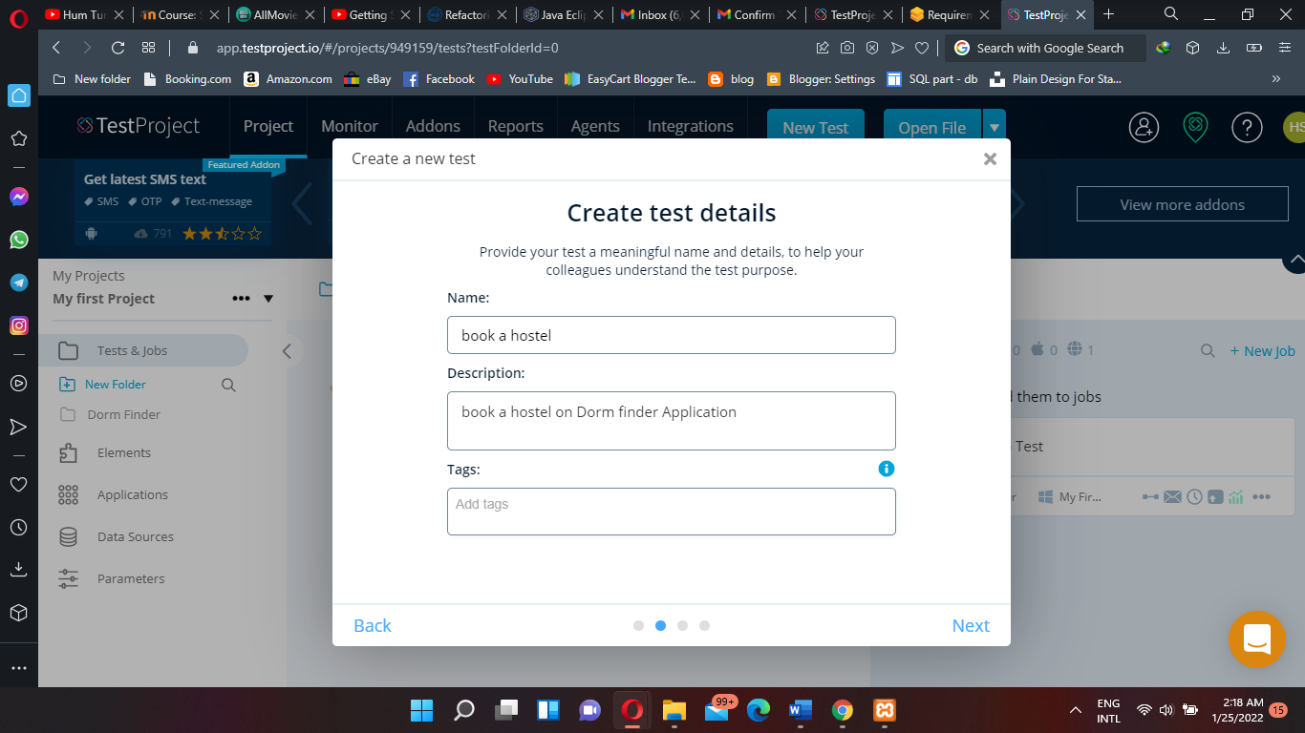

**Now selecting the web application and paste the URL or location.**

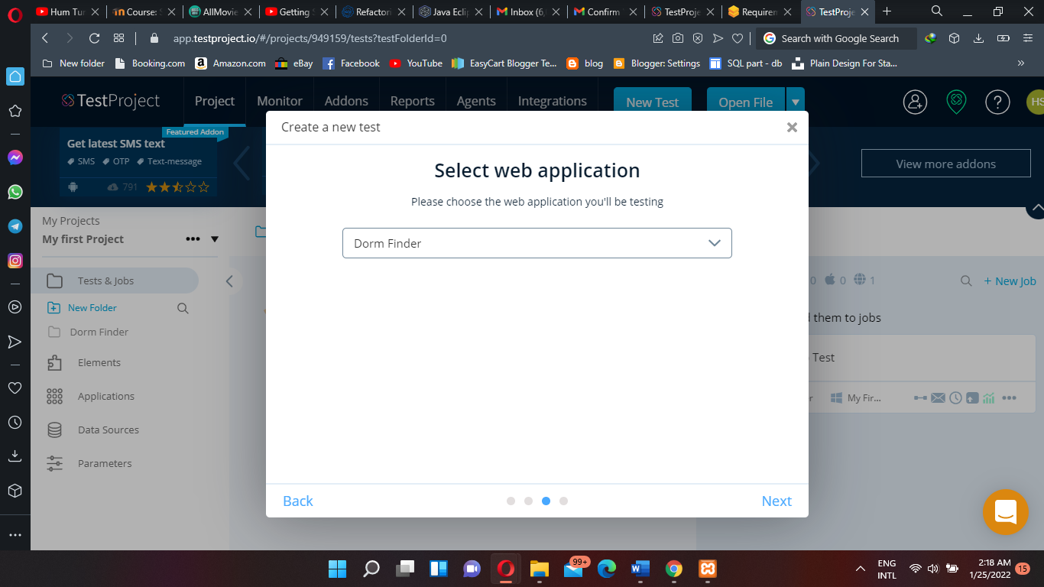

**Now you select the recording the test case and then then click create**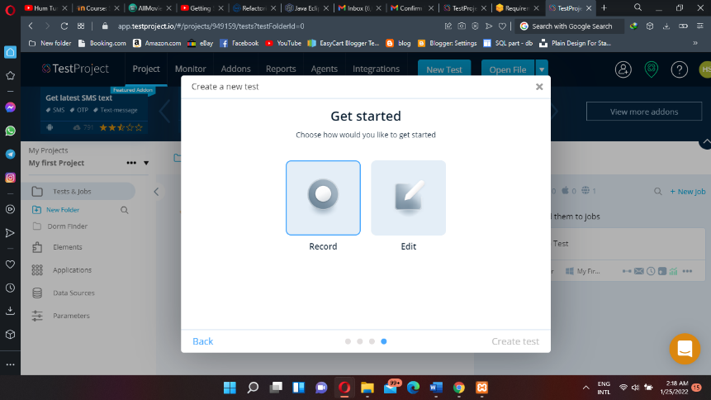

**Now perform the test step by step and it’s all recorded. Firstly, you have to login**

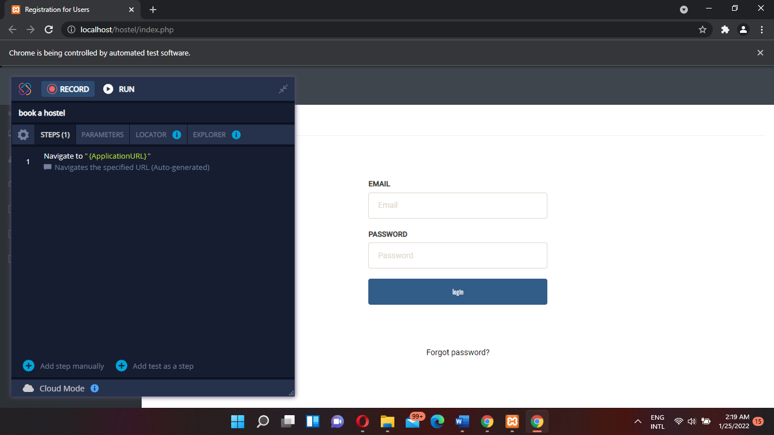

**Then you have to enter all information of hostel and also about yourself**

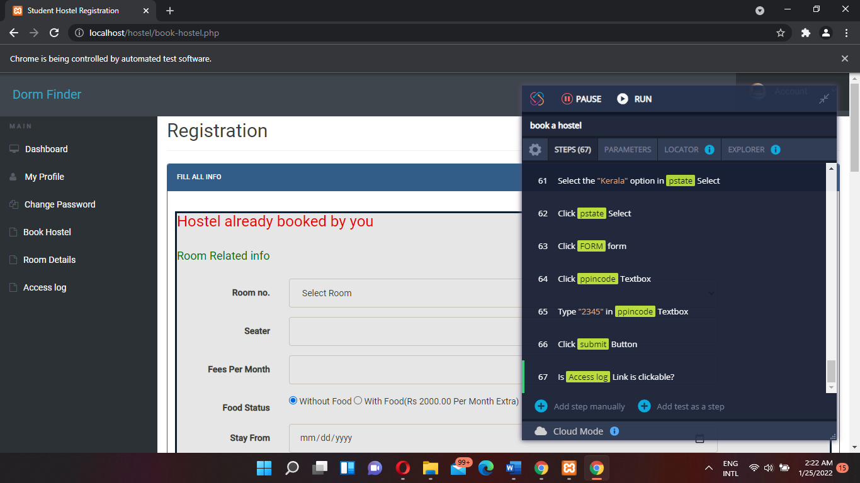

**After all, done the test is shown in the dashboard then you have to create a job and run the web test.**

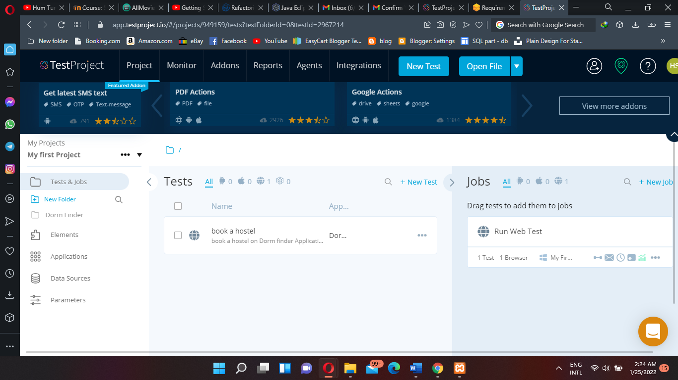

**That’s the report of the test case.**

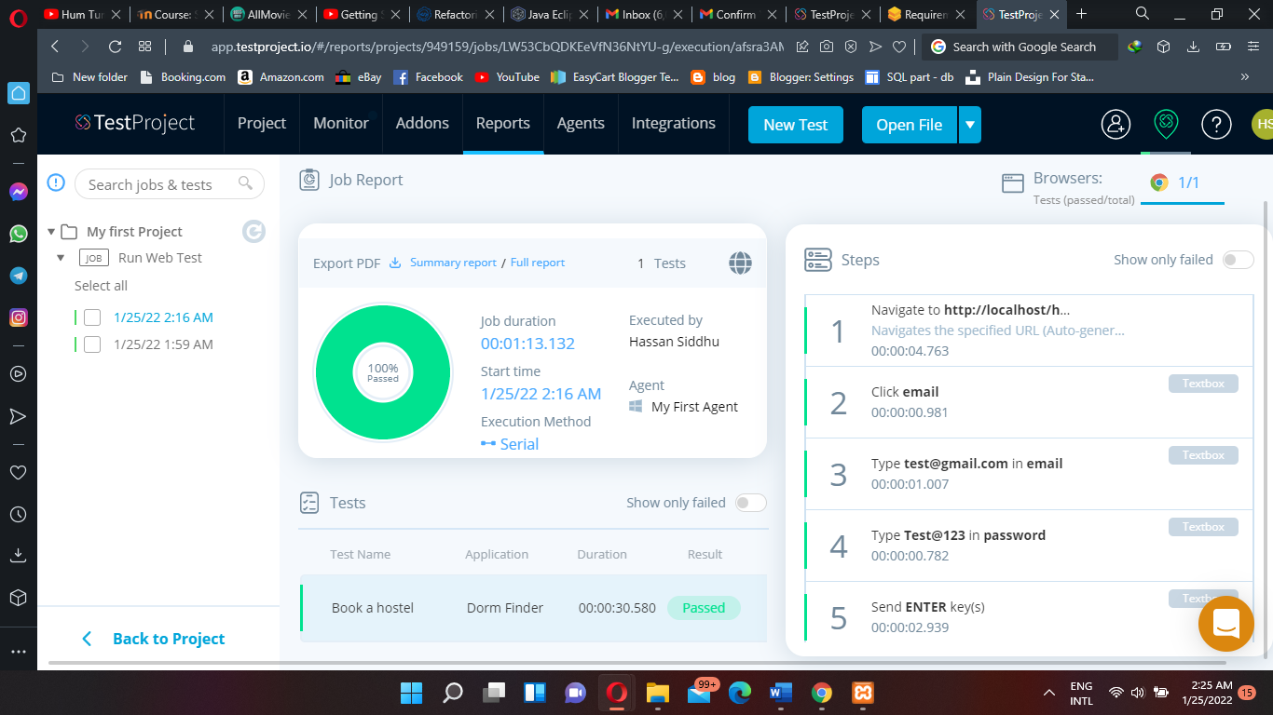

**It is all working of the software tool step by step.**

**2nd Test**

**Testing to show the room detail and the connection of the room.**

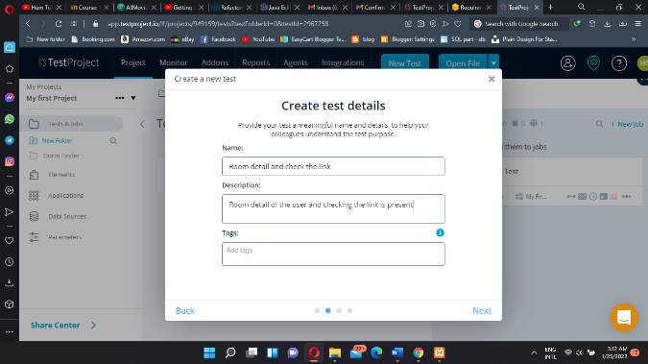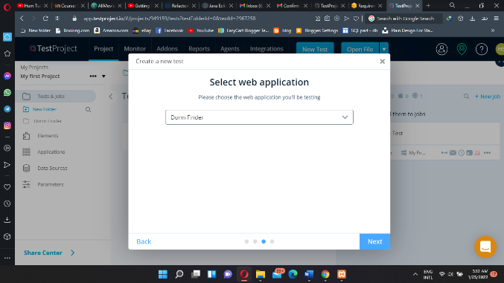

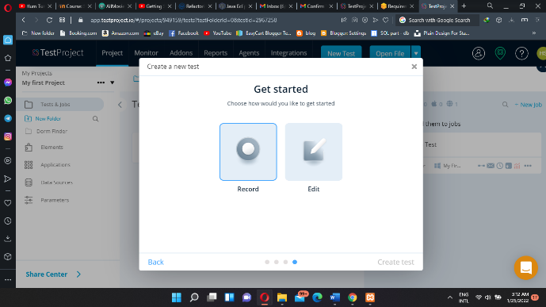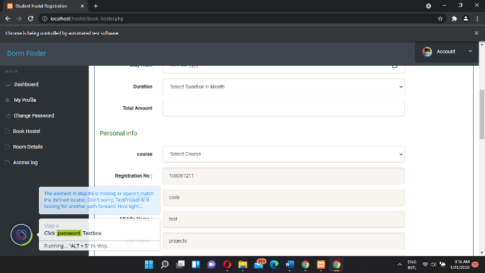

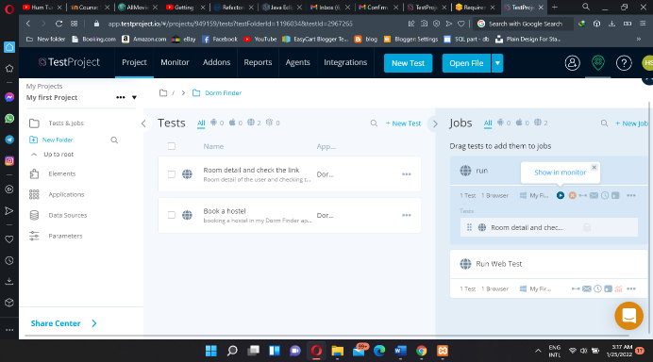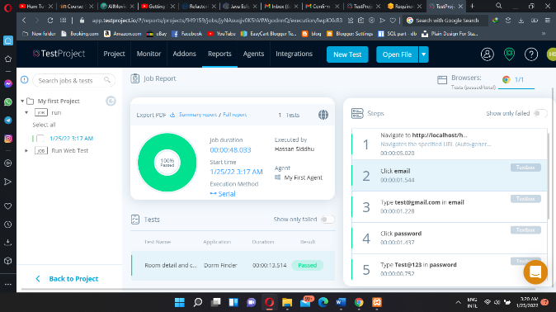

**3rd Test:**

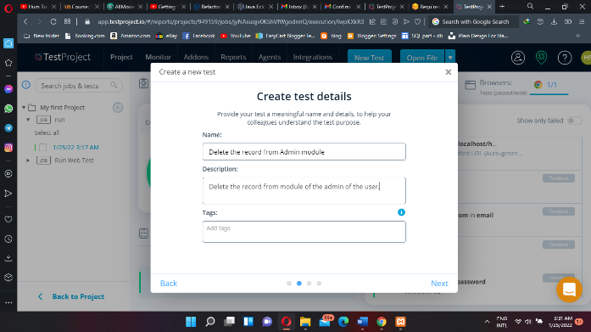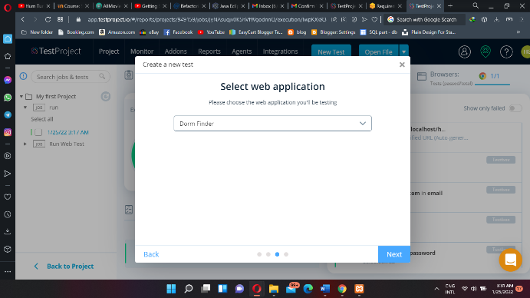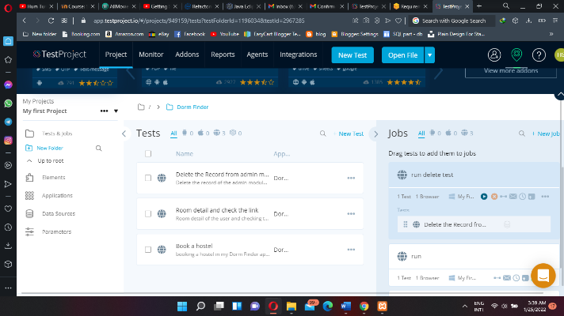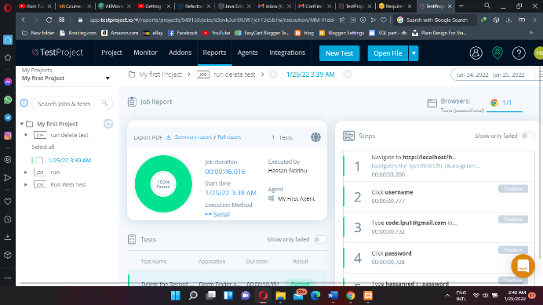

**Data Driven Testing:**

**Firstly, you will take recently add test cases and set the parameters**

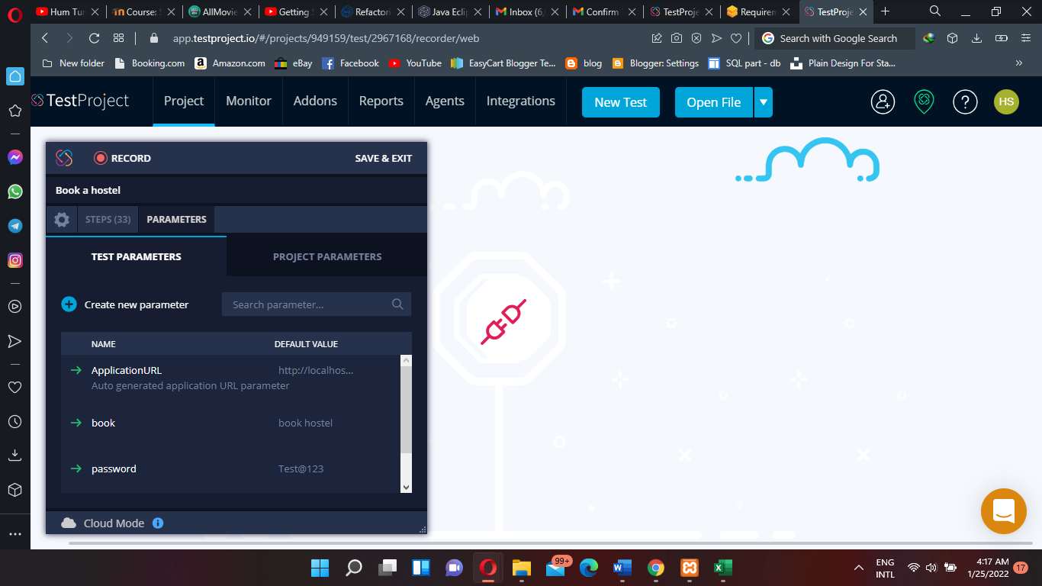

**Then you have to download the CSV file and give the valid and invalid information then the tool will check automatically.**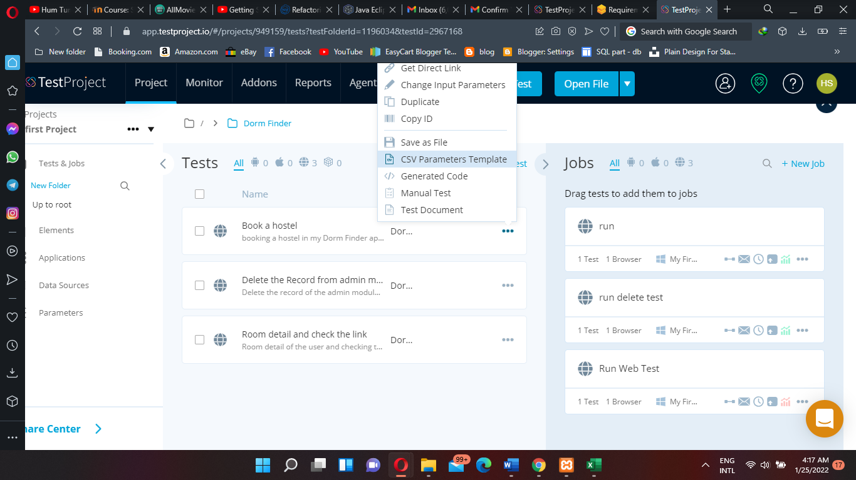

**Put the valid and invalid information.**

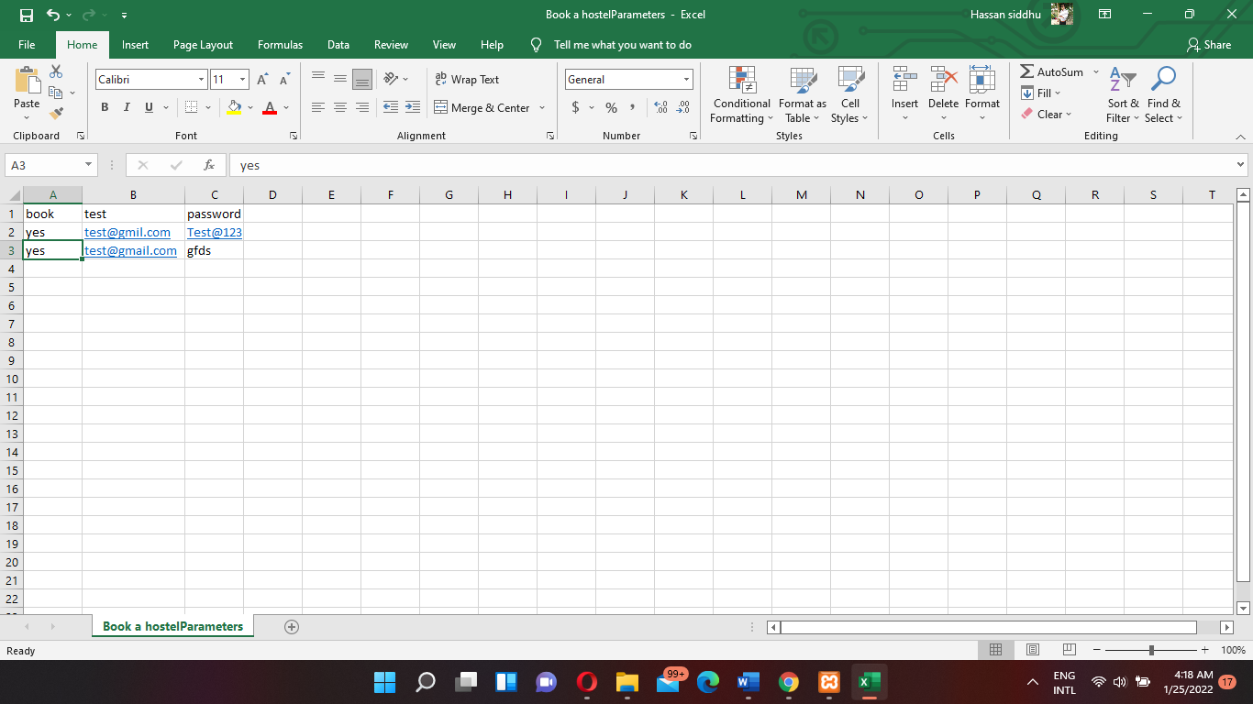

**Add the CSV file to data sources.**

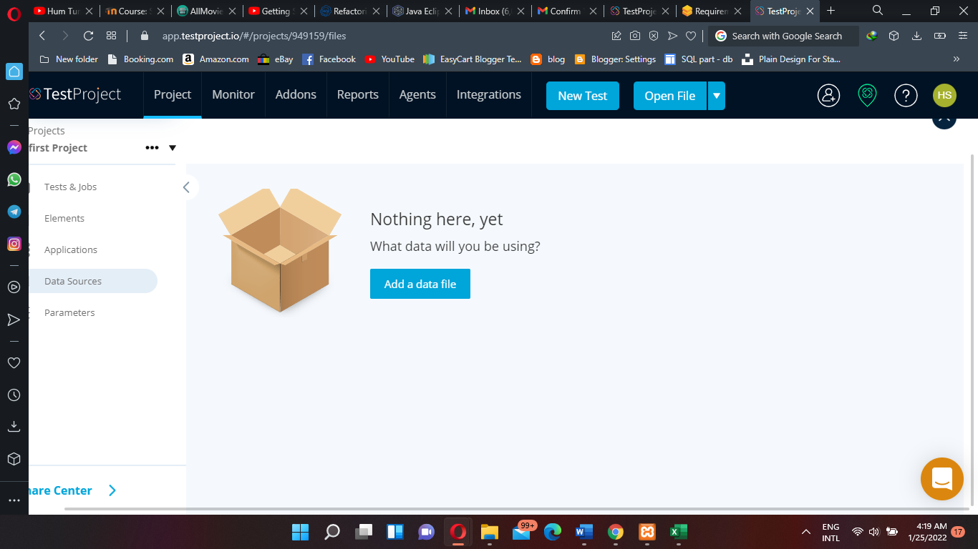

**Run the test case and add the source file.**

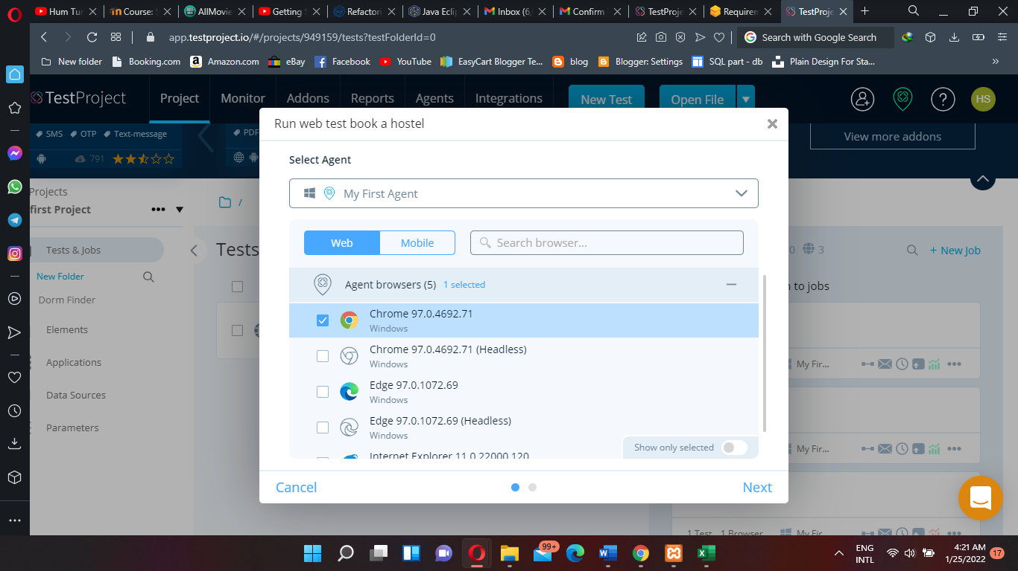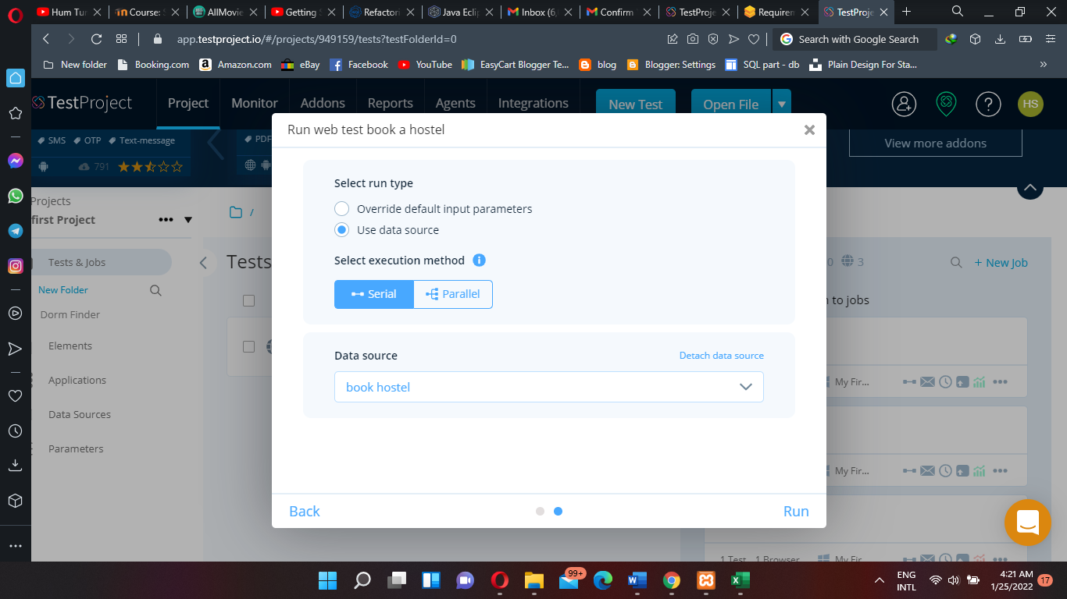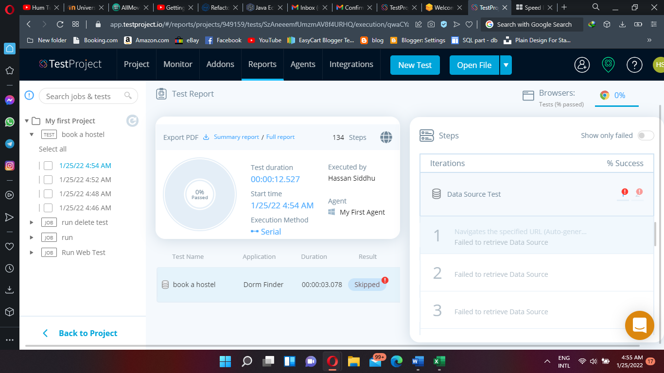

**That’s the summary of the test-driven test case.**